DA Assignment – 1

Upload the dataset to Cognos Analytics:

1. Open Cognos Analytics and navigate to the "Content" page. 2. Click on the "New Folder" button to create a new folder where you want to store your dataset.

3. Click on the folder where you want to store your dataset. 4. Click on the "Upload" button in the top-right corner of the page. 5. Select the dataset file from your computer and click on the "Open" button.

6. In the "Upload" dialog box, you can specify a name for the dataset and select the file type. You can also choose whether to use the first row of the file as column headers.

7. Click on the "Upload" button to upload the dataset to Cognos Analytics.

8. Once the upload is complete, you can click on the name of the dataset to view the data and start exploring and visualizing it.

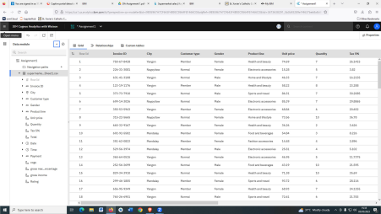Delete the unnecessary columns:

1.Open your dataset in Cognos Analytics.

2. Navigate to the "Data" tab.

3. Click on the drop-down arrow next to the name of the dataset to display the available options.

4. Select "Edit" to open the Data Module Editor.

5. In the Data Module Editor, you will see a list of tables and columns.Locate the table that contains the columns you want to delete.

6. Click on the table name to display the available columns.

7. To delete a column, click on the column name to select it, and then click on the "Delete" button at the top of the screen.

8. Repeat this process for each column you want to delete.

9. Once you have deleted all the unnecessary columns, click on the "Save" button to save your changes.

10.Close the Data Module Editor and return to the "Data" tab to view the updated dataset.

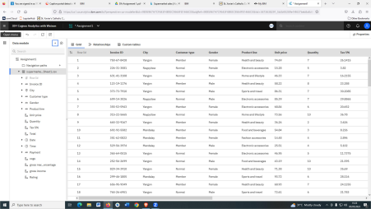Create a data module:

1. Open Cognos Analytics and navigate to the "Content" page. 2. Click on the folder where you want to store your data module. 3. Click on the "New" button in the top-right corner of the page and select "Data Module" from the drop-down menu.

4. In the "New Data Module" dialog box, enter a name for your data module and select the database connection you want to use.

5. Click on the "Create" buƩon to create the data module.

6. In the Data Module Editor, you will see a list of tables and columns from your selected database connecƟon. You can drag and drop tables

onto the canvas to create a visual representaƟon of your data model. 7. You can also rename columns, create calculated columns, and perform other data transformaƟons using the tools available in the Data Module Editor.

8. Once you have created your data module, you can save it and use it to create reports and visualizaƟons in Cognos AnalyƟcs

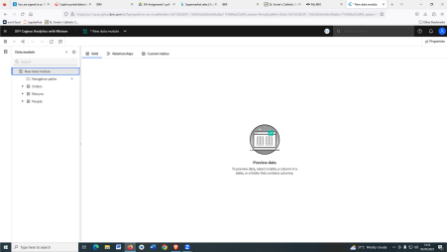Explore and visualize the dataset:

1. Open your data module in Cognos Analytics.

2. Click on the "Explore Data" button to open the Data Exploration page.

3. You will see a list of tables and columns on the left side of the page. Drag and drop the columns you want to explore onto the canvas on the right side of the page.

4. Once you have added your columns, you can use the "Filter" pane

to filter the data based on your requirements.

5. You can also use the "Visualization" pane to create visualizations of your data. Click on the "Visualize" button to display the available visualization types.

6. Select the type of visualization you want to create, such as a bar chart,line chart, or pie chart.

7. Drag and drop the columns you want to use for your visualization onto the appropriate fields in the "Visualization" pane.

8. Customize your visualization as needed, such as changing the colors or labels.

9. Once you have created your visualization, you can save it and add it to a dashboard or report.

